Trapezohedron (Deltohedron)

Definition
# Source: AI Source: Provided by: [Data Path: Persons Table -> ID Column: 1, Name_En Column: Motasem Essam] -> From: [ChatGPT] on [7/25/2026]
A Trapezohedron is a convex polyhedron whose faces are congruent kite-shaped quadrilaterals, arranged in two opposing rings around a central axis.
Each face is typically a kite with two pairs of adjacent equal-length sides. The faces meet around two opposite vertices, producing a solid with rotational symmetry.
A trapezohedron is also known as a deltohedron.

Simple Definition
# Source: AI Source: Provided by: [Data Path: Persons Table -> ID Column: 1, Name_En Column: Motasem Essam] -> From: [ChatGPT] on [7/25/2026]
A trapezohedron is a three-dimensional solid made entirely of identical kite-shaped faces, arranged symmetrically around an axis.
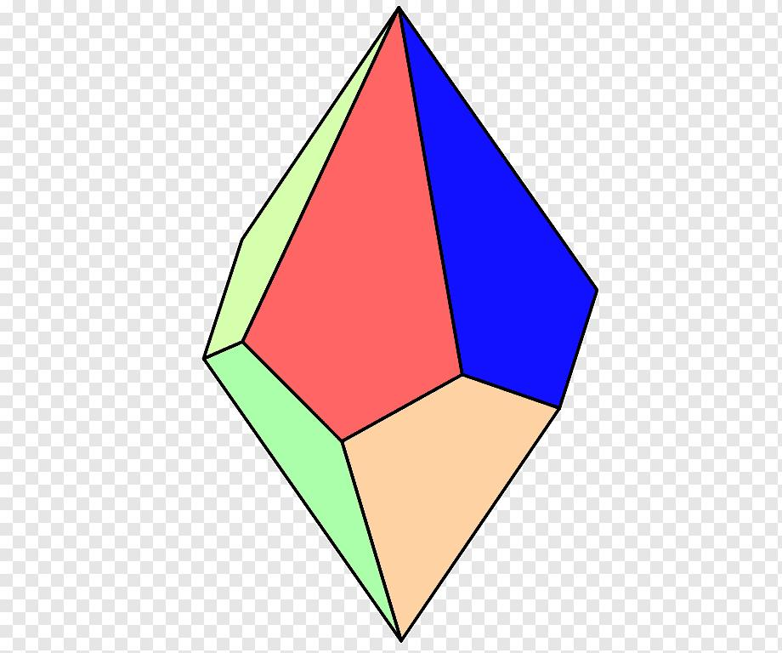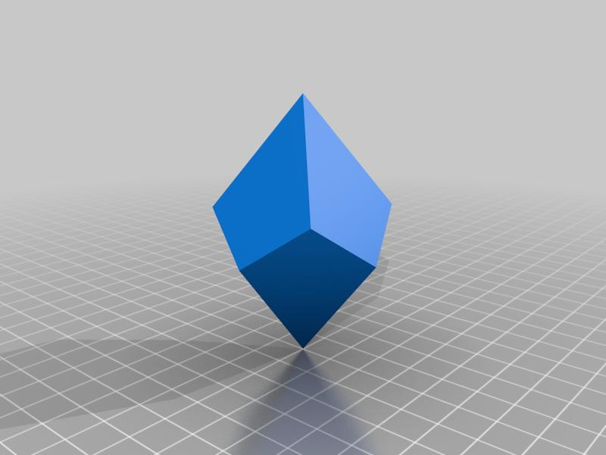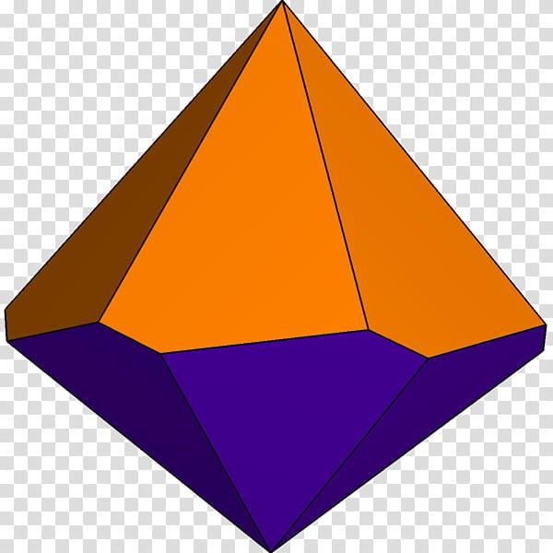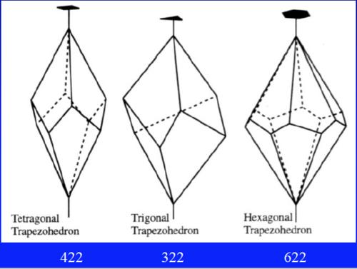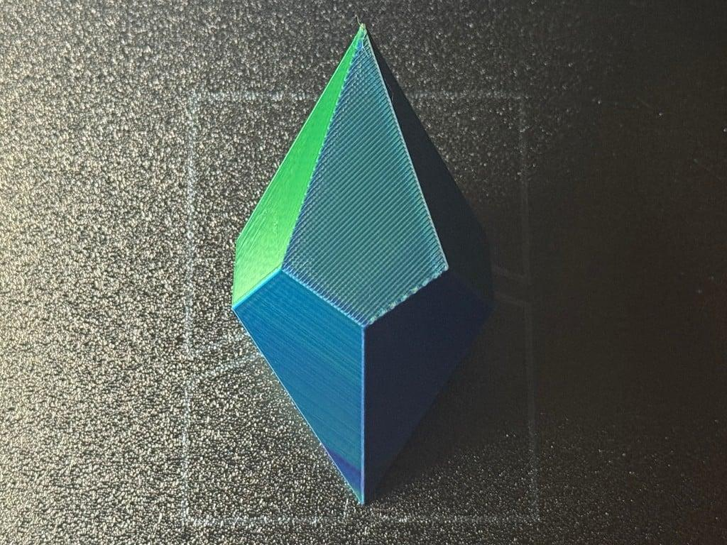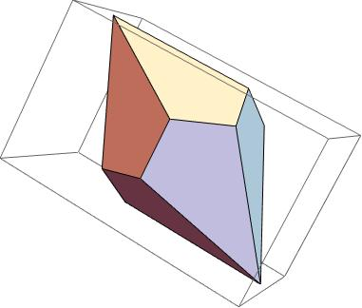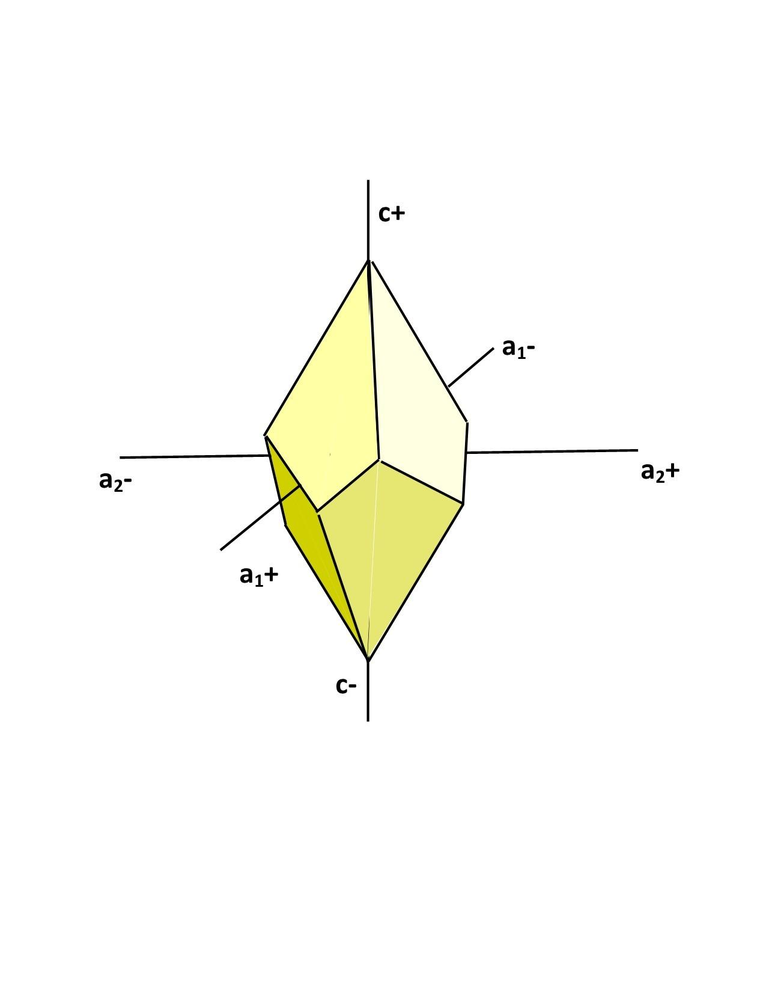

Geometric Structure
# Source: AI Source: Provided by: [Data Path: Persons Table -> ID Column: 1, Name_En Column: Motasem Essam] -> From: [ChatGPT] on [7/25/2026]
A typical trapezohedron has the following elements:
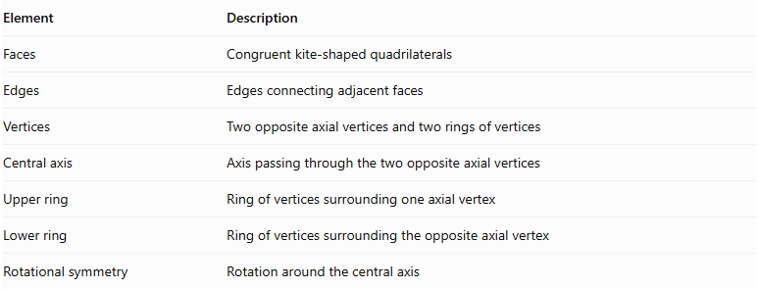
Element | Description
Faces | Congruent kite-shaped quadrilaterals
Edges | Edges connecting adjacent faces
Vertices | Two opposite axial vertices and two rings of vertices
Central axis | Axis passing through the two opposite axial vertices
Upper ring | Ring of vertices surrounding one axial vertex
Lower ring | Ring of vertices surrounding the opposite axial vertex
Rotational symmetry | Rotation around the central axis

Main Classification
# Source: AI Source: Provided by: [Data Path: Persons Table -> ID Column: 1, Name_En Column: Motasem Essam] -> From: [ChatGPT] on [7/25/2026]
Trapezohedra are commonly classified according to the number of kite-shaped faces.
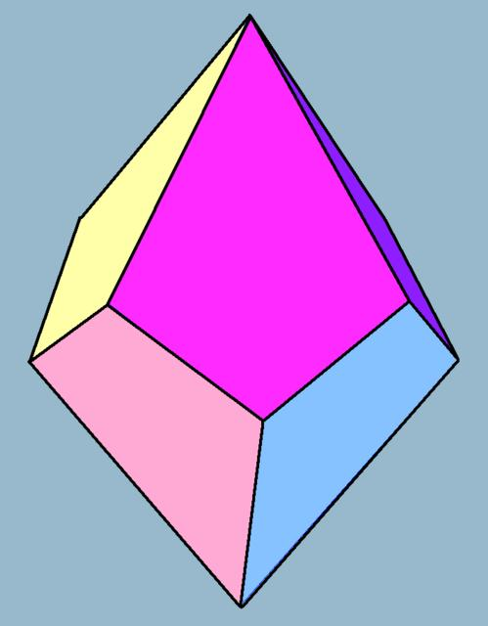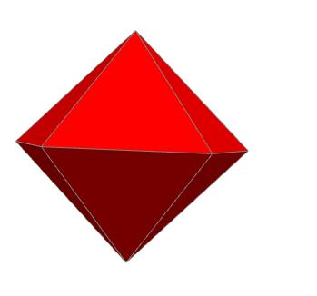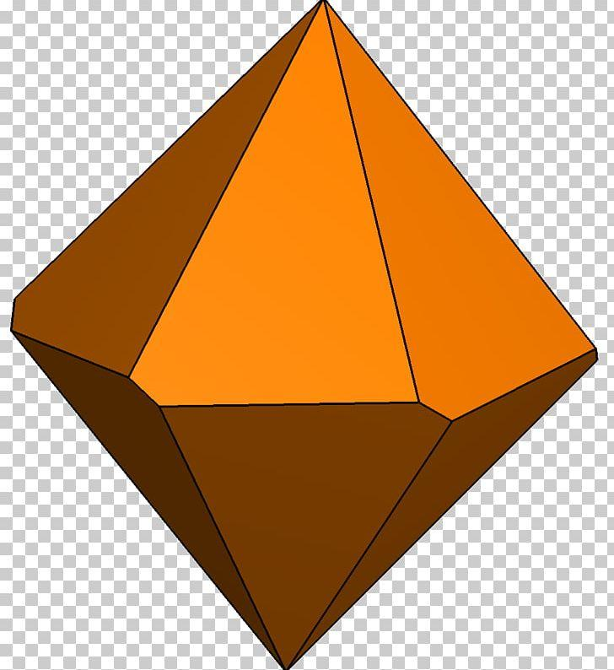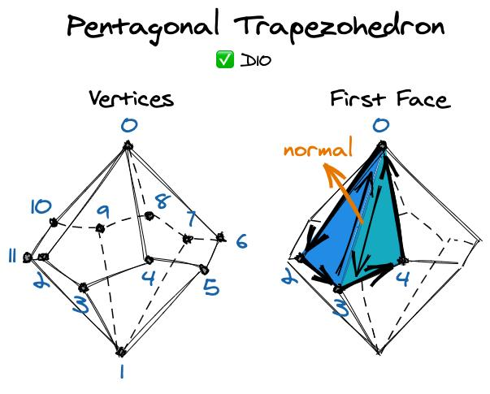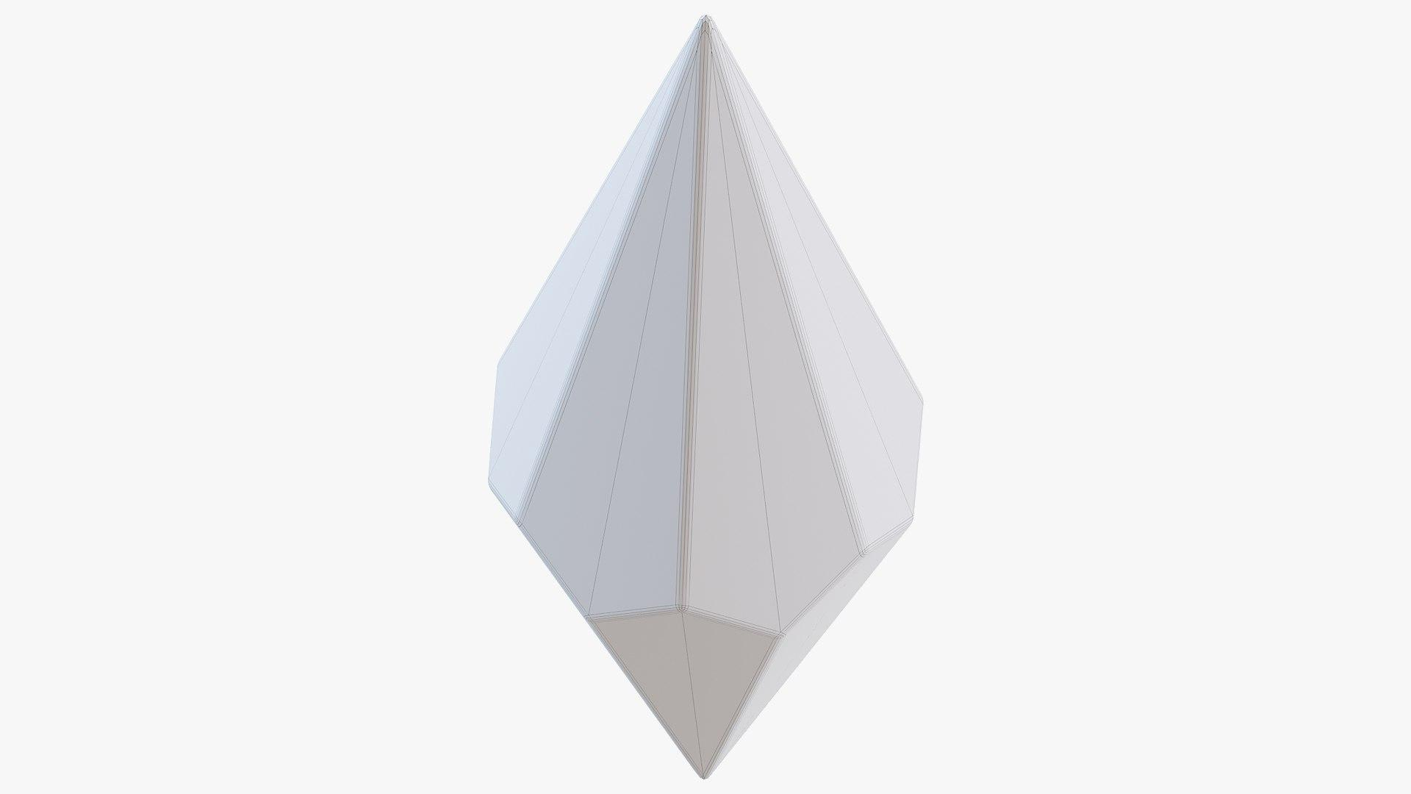
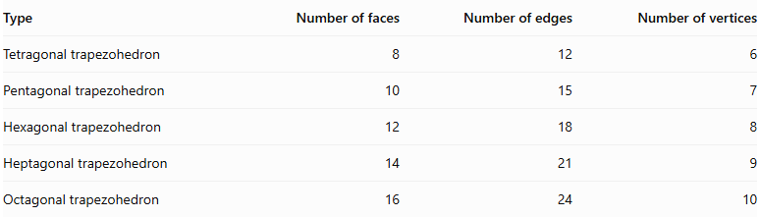
Type | Number of faces | Number of edges | Number of vertices
Tetragonal trapezohedron | 8 | 12 | 6
Pentagonal trapezohedron | 10 | 15 | 7
Hexagonal trapezohedron | 12 | 18 | 8
Heptagonal trapezohedron | 14 | 21 | 9
Octagonal trapezohedron | 16 | 24 | 10
For an $n$-gonal trapezohedron, where $n≥3$:
$$F=2n$$
$$E=3n$$
$$V=n+2$$
Here, $F$ represents faces, $E$ edges, and $V$ vertices.

Geometric Properties

A. Faces
# Source: AI Source: Provided by: [Data Path: Persons Table -> ID Column: 1, Name_En Column: Motasem Essam] -> From: [ChatGPT] on [7/25/2026]
- All faces are congruent kites.
- Each face has four sides.
- Each face has two pairs of adjacent equal sides.
- The faces are arranged symmetrically around the central axis.

B. Edges
# Source: AI Source: Provided by: [Data Path: Persons Table -> ID Column: 1, Name_En Column: Motasem Essam] -> From: [ChatGPT] on [7/25/2026]
There are two principal groups of edges:
- Upper edges: connect the upper axial vertex to the surrounding ring of vertices through the faces.
- Lower edges: connect the lower axial vertex to the surrounding ring of vertices through the faces.

C. Vertices
# Source: AI Source: Provided by: [Data Path: Persons Table -> ID Column: 1, Name_En Column: Motasem Essam] -> From: [ChatGPT] on [7/25/2026]
The vertices consist of:
- One upper axial vertex.
- One lower axial vertex.
- $n$ vertices in the middle ring.
Total:
$$V=n+2$$

Mathematical Properties

A. Euler's Formula
# Source: AI Source: Provided by: [Data Path: Persons Table -> ID Column: 1, Name_En Column: Motasem Essam] -> From: [ChatGPT] on [7/25/2026]
For a convex trapezohedron:
$$V-E+F=2$$
Substituting the general formulas:
$$(n+2)-3n+2n=2$$

B. Number of Faces
# Source: AI Source: Provided by: [Data Path: Persons Table -> ID Column: 1, Name_En Column: Motasem Essam] -> From: [ChatGPT] on [7/25/2026]
$$F=2n$$

C. Number of Edges
# Source: AI Source: Provided by: [Data Path: Persons Table -> ID Column: 1, Name_En Column: Motasem Essam] -> From: [ChatGPT] on [7/25/2026]
$$E=3n$$

D. Number of Vertices
# Source: AI Source: Provided by: [Data Path: Persons Table -> ID Column: 1, Name_En Column: Motasem Essam] -> From: [ChatGPT] on [7/25/2026]
$$V=n+2$$

Symmetry
# Source: AI Source: Provided by: [Data Path: Persons Table -> ID Column: 1, Name_En Column: Motasem Essam] -> From: [ChatGPT] on [7/25/2026]
A typical $n$-gonal trapezohedron has:
- An $n$-fold rotational symmetry axis through its two axial vertices.
- A set of symmetry planes containing the central axis when the trapezohedron has the corresponding regular symmetric arrangement.
- A central inversion symmetry for the standard symmetric form.
The precise symmetry group depends on the geometry of the trapezohedron.

Constructing Trapezohedron in Solid Geometry

Geometric Instruments Used
# Source: AI Source: Provided by: [Data Path: Persons Table -> ID Column: 1, Name_En Column: Motasem Essam] -> From: [ChatGPT] on [7/25/2026]
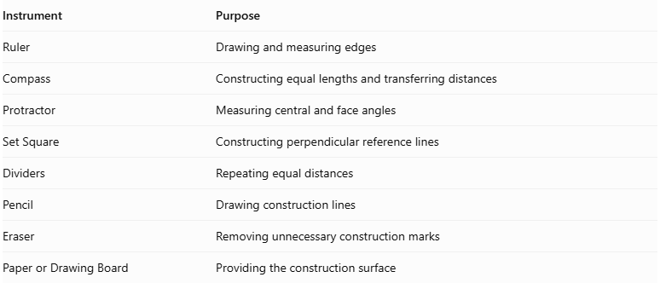
Instrument | Purpose
Ruler | Drawing and measuring edges
Compass | Constructing equal lengths and transferring distances
Protractor | Measuring central and face angles
Set Square | Constructing perpendicular reference lines
Dividers | Repeating equal distances
Pencil | Drawing construction lines
Eraser | Removing unnecessary construction marks
Paper or Drawing Board | Providing the construction surface

Instrument-Based Construction Procedures

Symmetry-Based Construction
# Source: AI Source: Provided by: [Data Path: Persons Table -> ID Column: 1, Name_En Column: Motasem Essam] -> From: [ChatGPT] on [7/25/2026]
- Draw a vertical reference line representing the principal symmetry axis.
- Mark the upper and lower axial vertices.
- Construct an equatorial polygon with the required number of vertices.
- Divide the surrounding angular arrangement into equal sections when constructing a symmetric form.
- Connect each equatorial vertex to the upper and lower axial vertices.
- Join neighboring equatorial vertices to complete the kite-shaped faces.
- Verify the face arrangement and overall symmetry.

Face-Based Construction
# Source: AI Source: Provided by: [Data Path: Persons Table -> ID Column: 1, Name_En Column: Motasem Essam] -> From: [ChatGPT] on [7/25/2026]
- Construct a kite-shaped quadrilateral using a ruler and compass.
- Determine the required number of faces.
- Construct congruent copies of the kite when producing a uniform trapezohedron.
- Arrange the faces in two groups around the upper and lower axial vertices.
- Join the corresponding edges of neighboring faces.
- Verify that all faces meet correctly without gaps or overlaps.

Edge-Based Construction
# Source: AI Source: Provided by: [Data Path: Persons Table -> ID Column: 1, Name_En Column: Motasem Essam] -> From: [ChatGPT] on [7/25/2026]
- Select the required edge lengths.
- Draw the upper and lower axial reference points.
- Construct the equatorial vertices using equal angular divisions.
- Connect the axial vertices to the equatorial vertices.
- Join neighboring equatorial vertices.
- Complete all kite-shaped faces.
- Check that the edge lengths match the selected construction pattern.

Projection-Based Representation
# Source: AI Source: Provided by: [Data Path: Persons Table -> ID Column: 1, Name_En Column: Motasem Essam] -> From: [ChatGPT] on [7/25/2026]
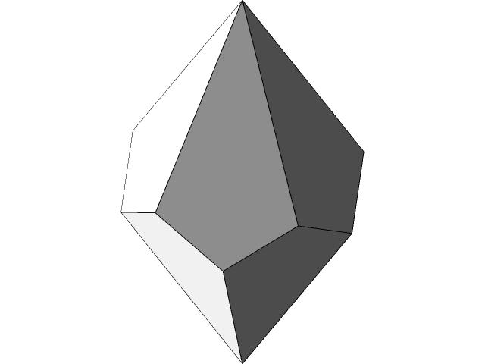
- Draw the principal axis.
- Represent the upper and lower axial vertices.
- Draw the equatorial polygon in the selected projection.
- Connect the equatorial vertices to both axial vertices.
- Complete the visible kite-shaped faces.
- Use dashed lines for hidden edges.
- Check the overall appearance and symmetry.

Net-Based Construction
# Source: AI Source: Provided by: [Data Path: Persons Table -> ID Column: 1, Name_En Column: Motasem Essam] -> From: [ChatGPT] on [7/25/2026]
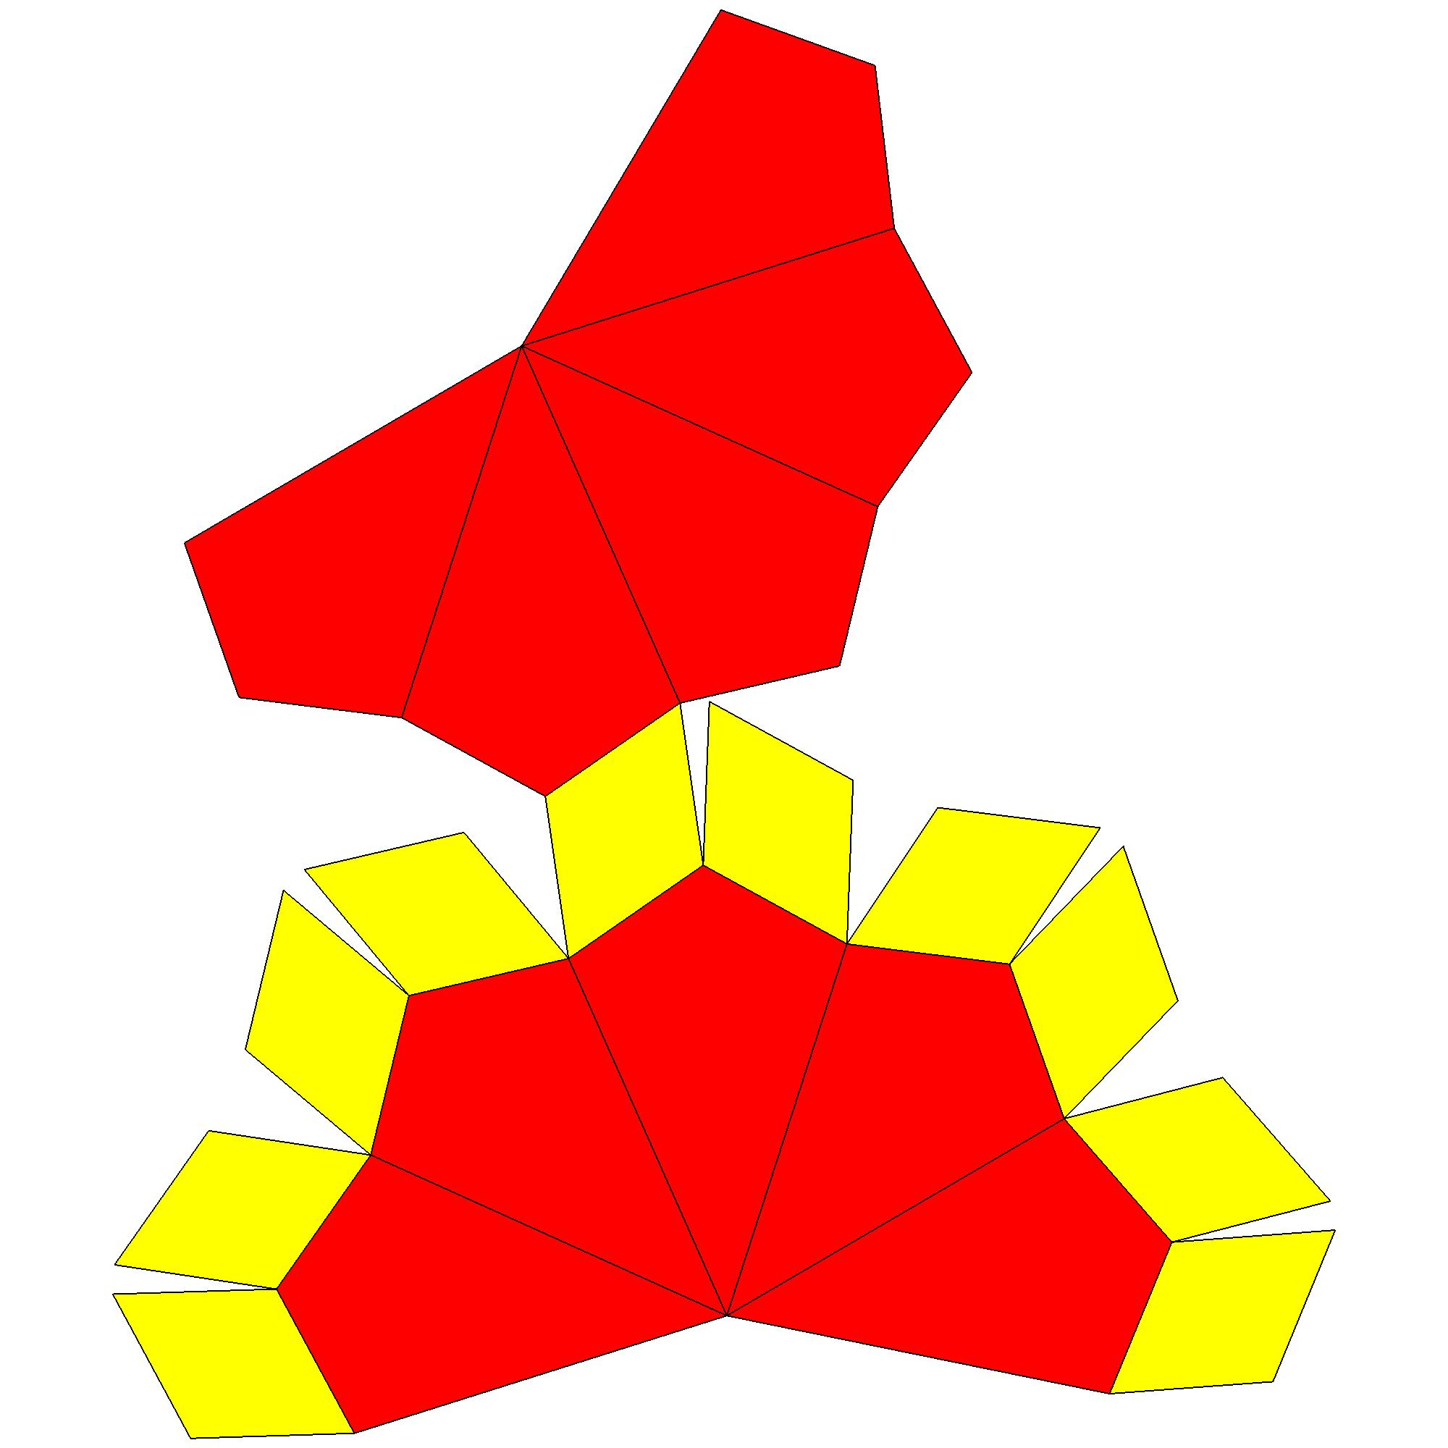
- Draw the required number of kite-shaped quadrilaterals.
- Arrange the faces in a connected net.
- Ensure that adjacent faces have matching edge lengths.
- Arrange the upper and lower face groups around the equatorial region.
- Add tabs if the net is intended for physical assembly.
- Cut and fold the net.
- Join the faces to form the trapezohedron.

Applications
# Source: AI Source: Provided by: [Data Path: Persons Table -> ID Column: 1, Name_En Column: Motasem Essam] -> From: [ChatGPT] on [7/25/2026]
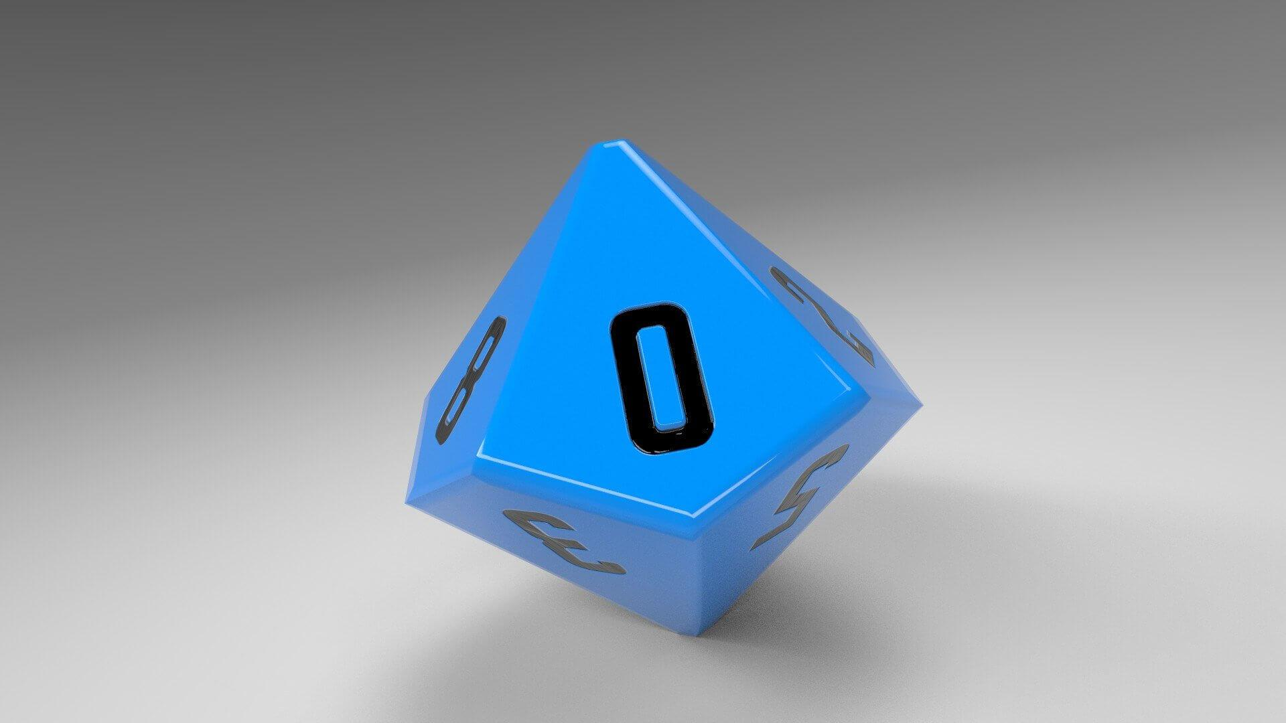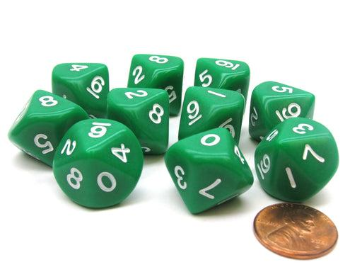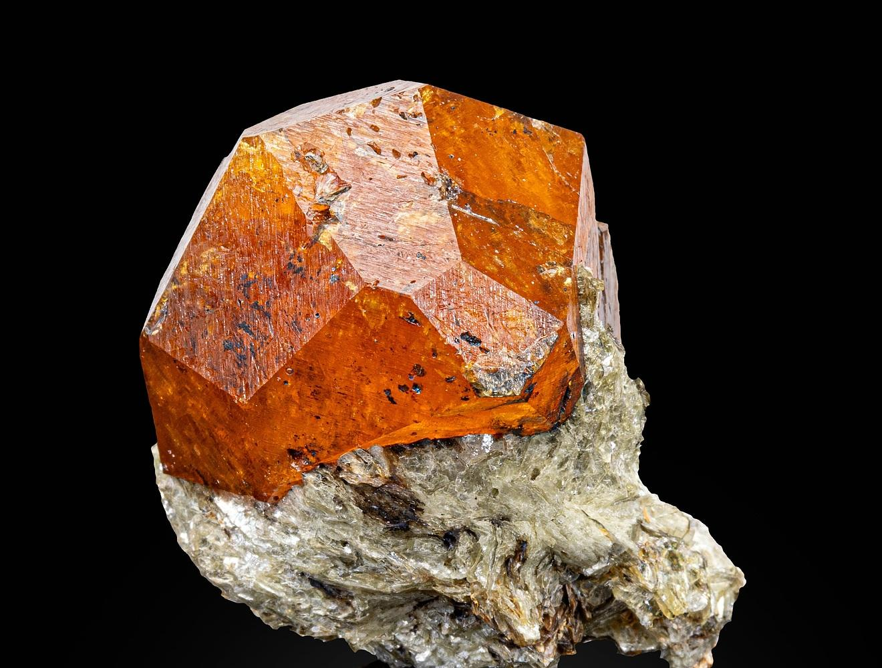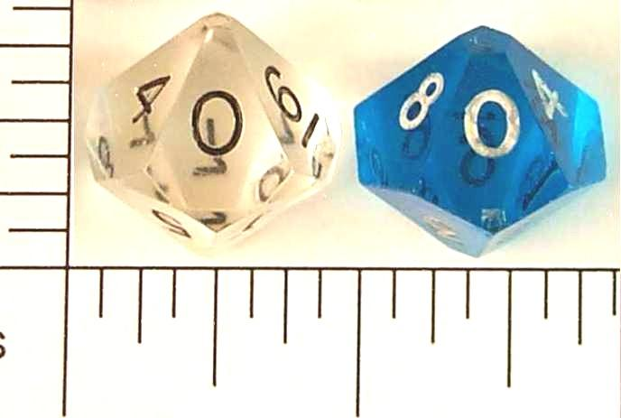
Trapezohedra appear in:
- Dice: The ten-sided die (D10) and twelve-sided die (D12) use trapezohedral forms.
- Crystallography: Certain crystal forms have trapezohedral symmetry.
- Mathematical geometry: Used to study polyhedral structures and rotational symmetry.
- Geometric modeling: Used in three-dimensional shape construction.

Key Points
# Source: AI Source: Provided by: [Data Path: Persons Table -> ID Column: 1, Name_En Column: Motasem Essam] -> From: [ChatGPT] on [7/25/2026]
- A trapezohedron is a convex polyhedron with congruent kite-shaped faces.
- Its faces are arranged around a central axis.
- It has two opposite axial vertices and a middle ring of vertices.
- An $n$-gonal trapezohedron has $2n$ faces, $3n$ edges, and $n+2$ vertices.
- It is also called a deltohedron.
- Its face count is always even.

Conclusion
# Source: AI Source: Provided by: [Data Path: Persons Table -> ID Column: 1, Name_En Column: Motasem Essam] -> From: [ChatGPT] on [7/25/2026]
A Trapezohedron is a polyhedron characterized by congruent kite-shaped faces arranged around a central axis. Its different forms are classified by the number of vertices in the middle ring, producing tetragonal, pentagonal, hexagonal, and other trapezohedra.
Classification note: A trapezohedron should not be confused with a trapezoidal prism or a trapezoidal-faced polyhedron. Its defining faces are kites, not trapezoids.

